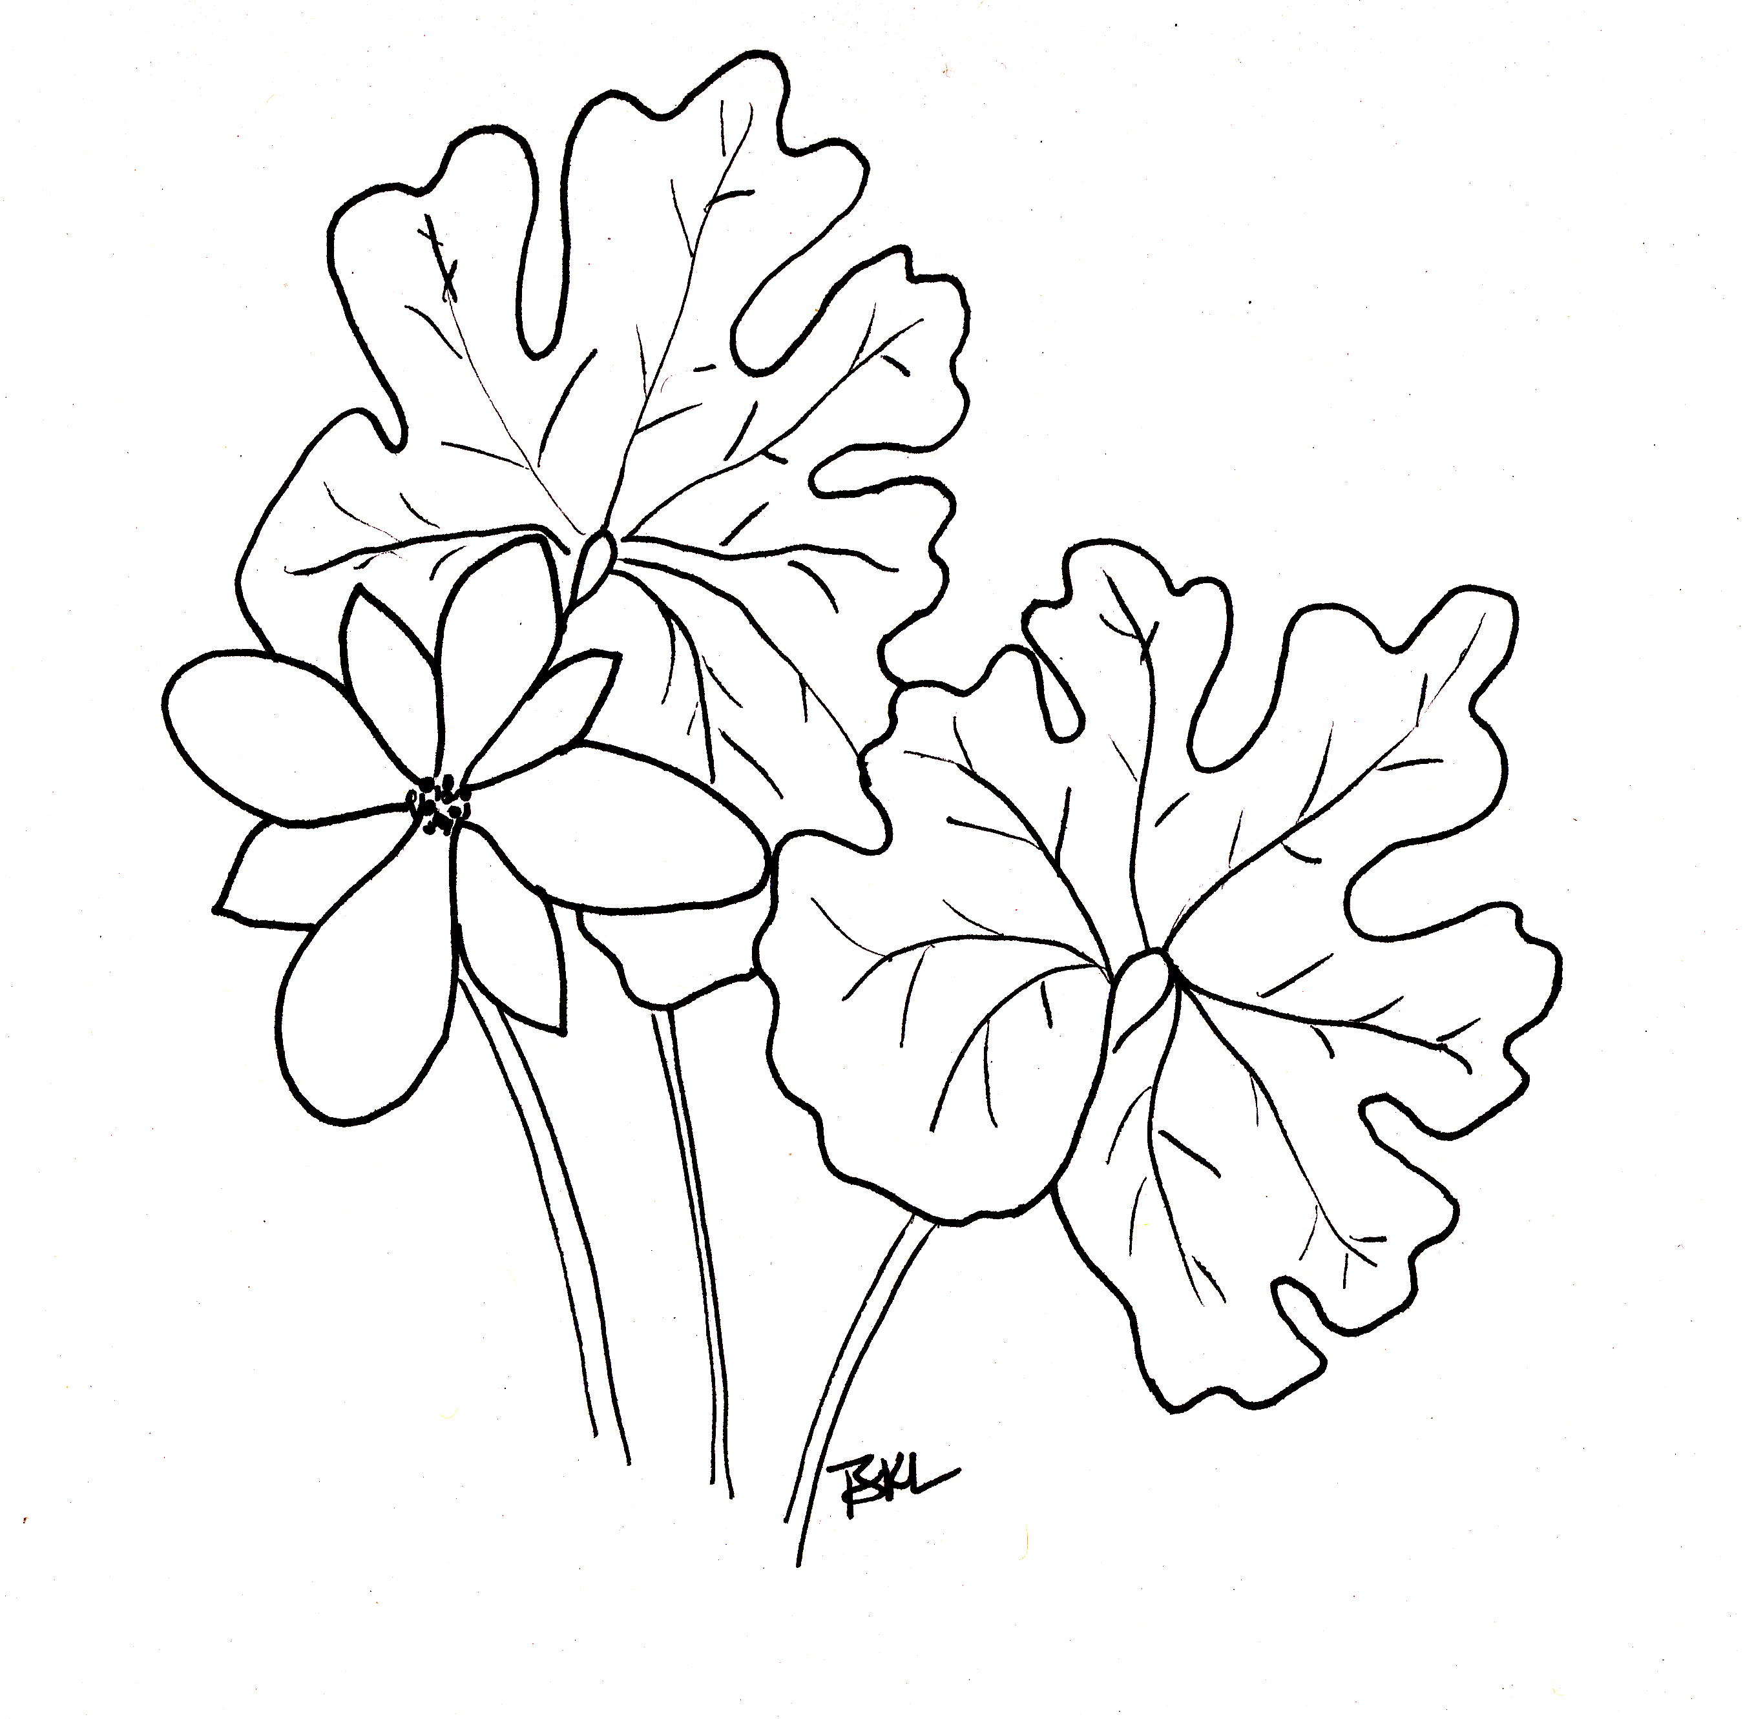
Nature Journaling

۞ Record in writing what you can not draw:
- Date
- Time of day
- Weather conditions
- What you hear?
- What you see at your feet, at eye level and above your head?
- Location: is it wet, dry, sloped, flat, full sun, partial sun, shaded?

۞ Draw what captures your interest, such as:
- Plants
  - Look how the plant is structured before you begin drawing.
  - Draw in detail, one or two leaves, stem, venation pattern, flower, seed head and root if visible.
  - Describe the size, texture and smell of the leaves and plant.
  - Make a note of some identifying characteristic of this plant, to help you remember it.
- An uprooted tree
- Animals, amphibians, birds, or insects you come across.

۞ Make notes about things you are curious about and what might be possible explanations for what you see. Be sure to describe where you are so you can find the spot again.

۞ Find a place off by yourself that appeals to you and sit quietly. Write a poem about that place.

Saint-Gaudens National Historic Site, 139 Saint-Gaudens Rd., Cornish, NH 03745 603-675-2175
www.nps.gov/saga

